ConfigMaps and Secrets

What are ConfigMaps?

A ConfigMap is an API object used to store non-confidential data in key-value pairs. How do you manage your application's configuration? For a Python or Node.js application, where do you store the configuration? ConfigMaps allow us to make a single change to the file itself, which can then effect many different pods using the same ConfigMap, thus cutting down on user error and deployment times.

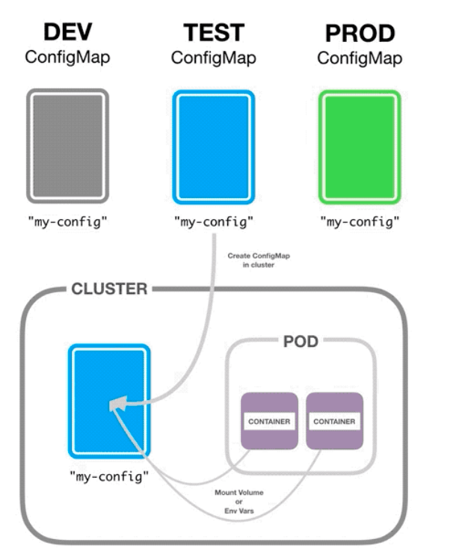

Kubernetes pods can use ConfigMaps as configuration files, environment variables or command-line arguments. ConfigMaps allow you to decouple environment-specific configurations from containers to make applications portable. Notice in the picture below we’re creating a ConfigMap for a video game. The player lives, types of enemies, and even colors are defined and would be applied to the application running on any pods using this particular ConfigMap.

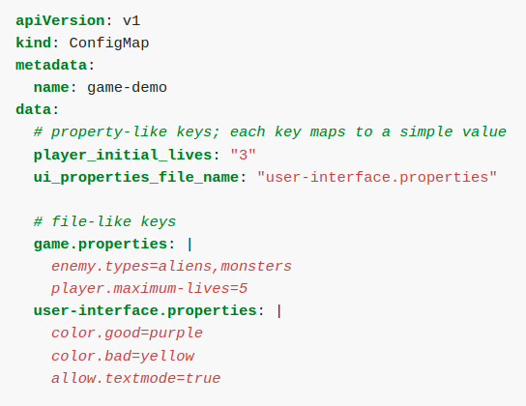

What are Secrets?

Secrets are a Kubernetes object intended for storing a small amount of sensitive data. To create a Secret ad-hoc choose a password and convert it to base64.

This is an imperative method to create a Secret, followed be the declarative YAML file. The command echo -n ‘KubernetesRocks!’ | base64 is taking the string and converting it into a hashed state.
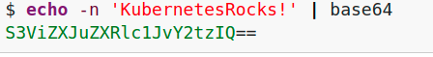
Secrets let us store and manage information, such as API keys, SSH keys, OAuth token, and more.
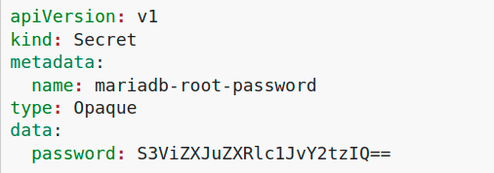

Storing sensitive data in Secrets is more secure than in plain text ConfigMaps or in Pod specifications. Using Secrets gives you control over how sensitive data is used, and reduces the risk of exposing the data to unauthorized users.
You can also encrypt Secrets at the application layer using a key you manage in Cloud KMS.

Hands On – Create a ConfigMap and Secret

I. Create a ConfigMap and a pod that will utilize it.
Let’s start creating a ConfigMap, applying it to the cluster, then verifying that its running. Notice that this ConfigMap is applying certain values to video game within our redis DB. Look in the data field and remember that player.maximum-lives is currently set to 5.

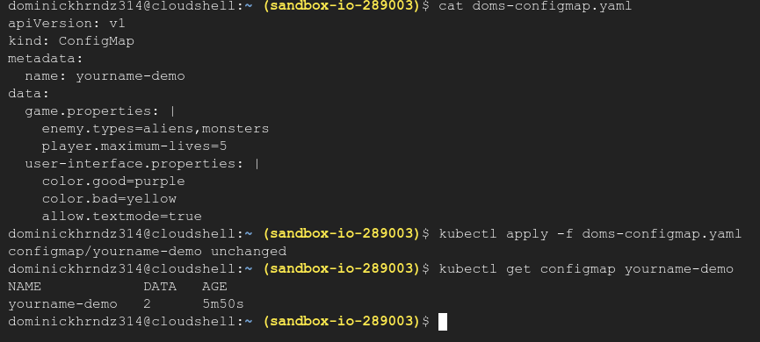
The data field would change characteristics of the app itself. Once we create our pod, we will then make a change to the ConfigMap to ensure that everything is working as expected.
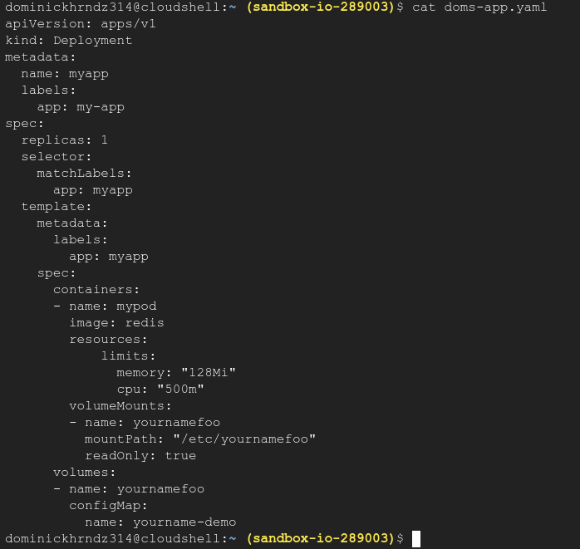
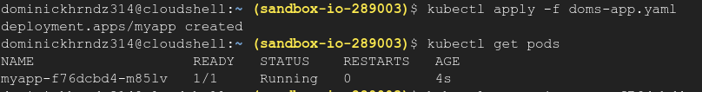
II. SSH to your Pod and verify the ConfigMap
Use the kubectl exec -it <yourpod> – /bin/bash command to SSH into your new pod. Once inside, navigate to the etc/<yournamefoo> folder.
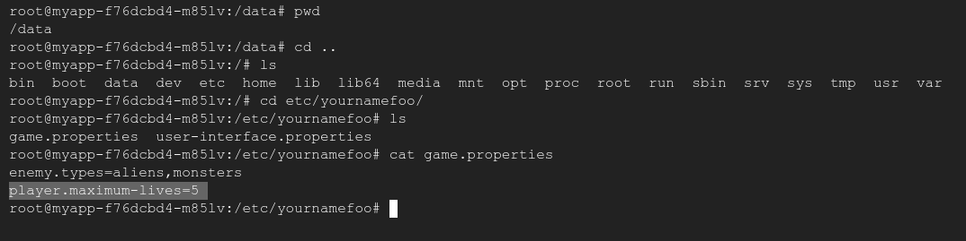
Inside, you will find fame files based on the data from our ConfigMap. Notice that max player lives is 5. Once you’ve verified this exit back to the cloudshell.
III. Change the ConfigMap
Edit the yourname-configmap.yaml file to reflect only 2 lives instead of 5.
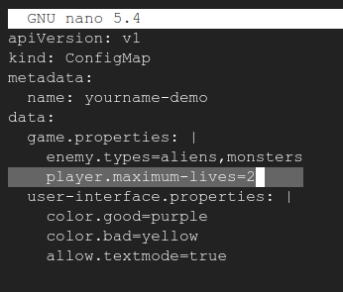

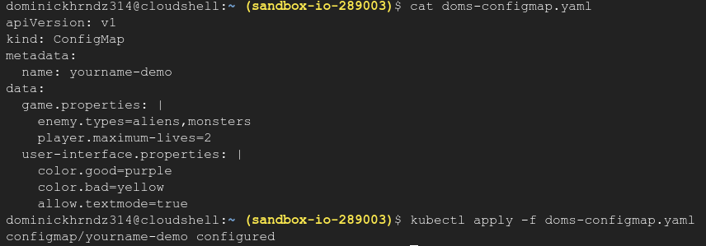
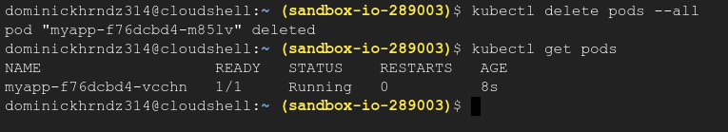
Verify your changes and then apply the new changes. Next, delete you pod and wait for it to redeploy so that the changes take effect.
IV. Check your Pod to verify
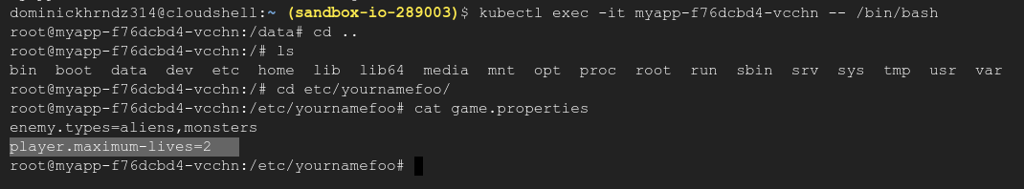
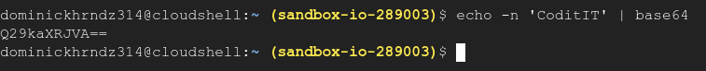
Using the same method as step 2, SSH into your new pod. Check the same directory and ensure the changes have taken place. You should
now have 2 max lives instead of 5.
VI. Create a secret
First, lets create a base64 secret and copy it for the YAML file. You need to copy down your hash so that we can paste it into your secrets.yaml file.
Create a secrets.yaml file and ensure that the password.file: field contains your new secret. Finally, apply your secret to the cluster.

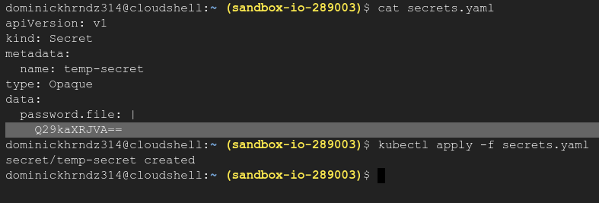

Your secrets deployment should be named temp-secret. Now, create your Pod with the temp-secret name referenced in the volumes field.

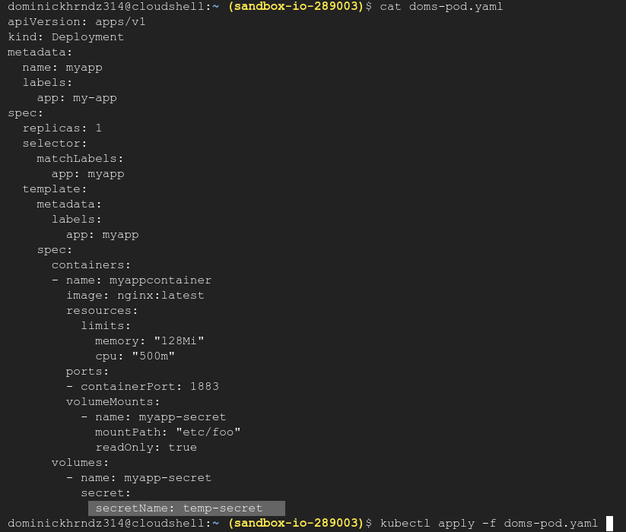
After you apply this deployment ssh into your pod with the kubectl exec -it <yourpod> – /bin/bash command. Find the etc/foo/ directory and cat the password.file. You should notice ‘CoditIT’ printed on the screen. The output may come out strangely in cloudshell. So long as it shows, you have completed this training.
